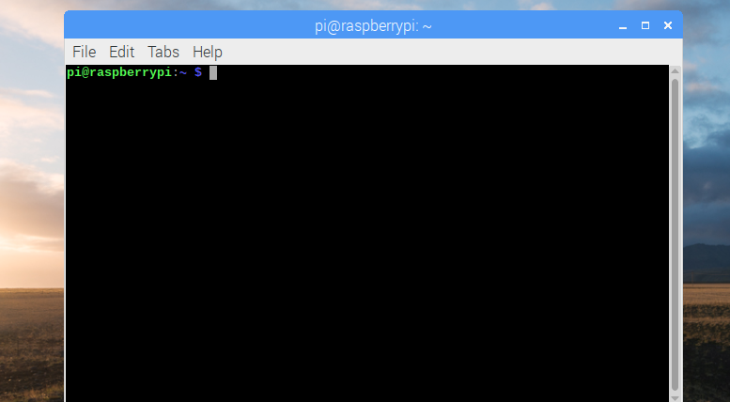

Open termial

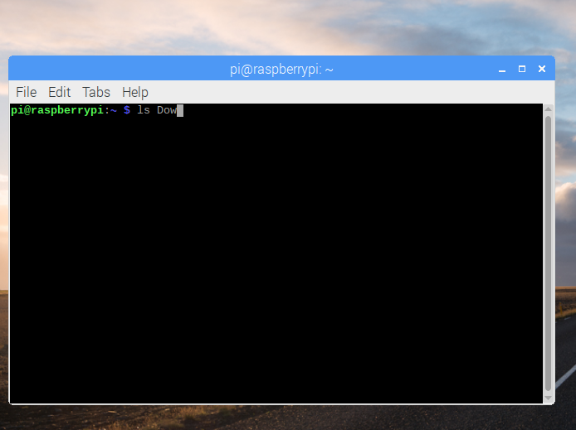

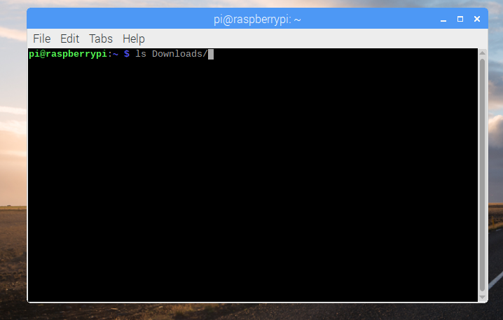

With [Tab], we are able to finish the command by just typing first couple of letters

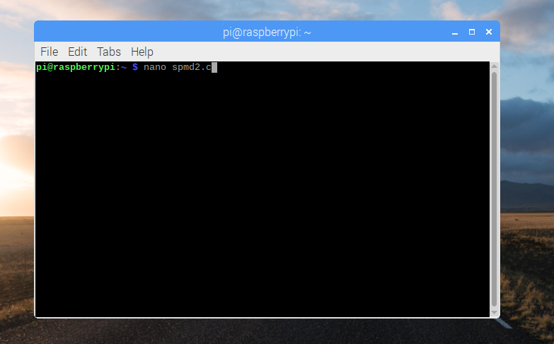

Creating a new c program called spmd2

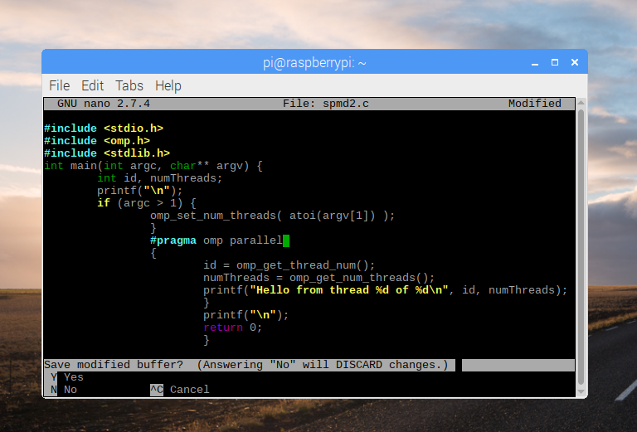

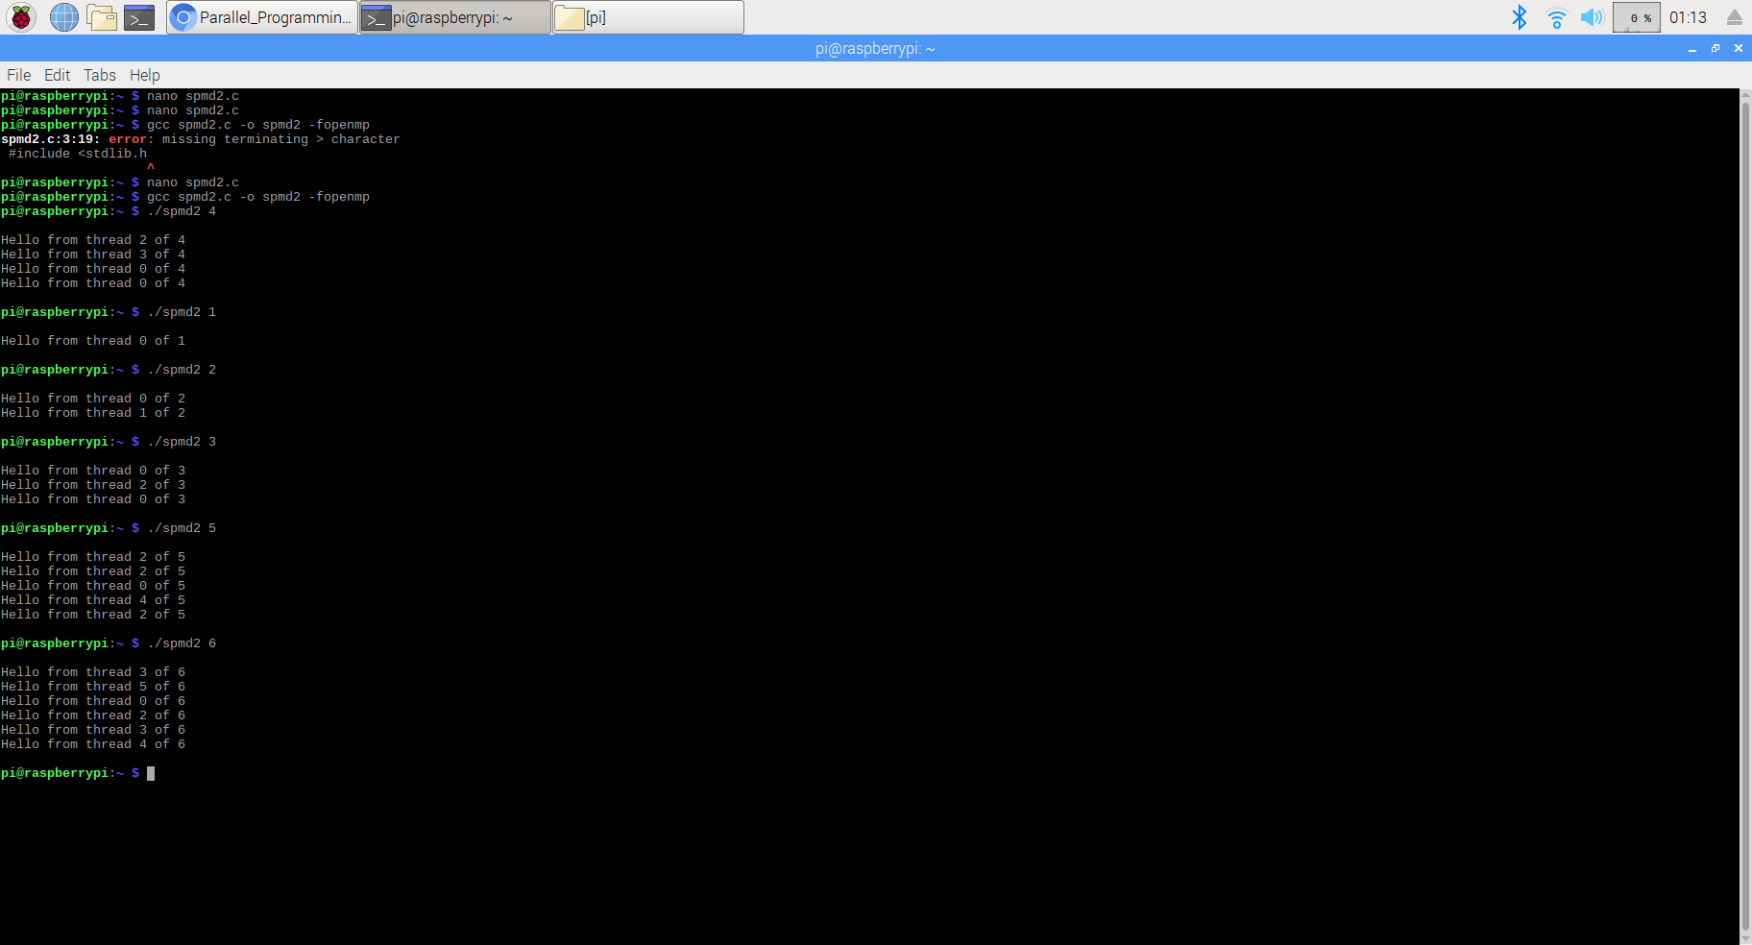

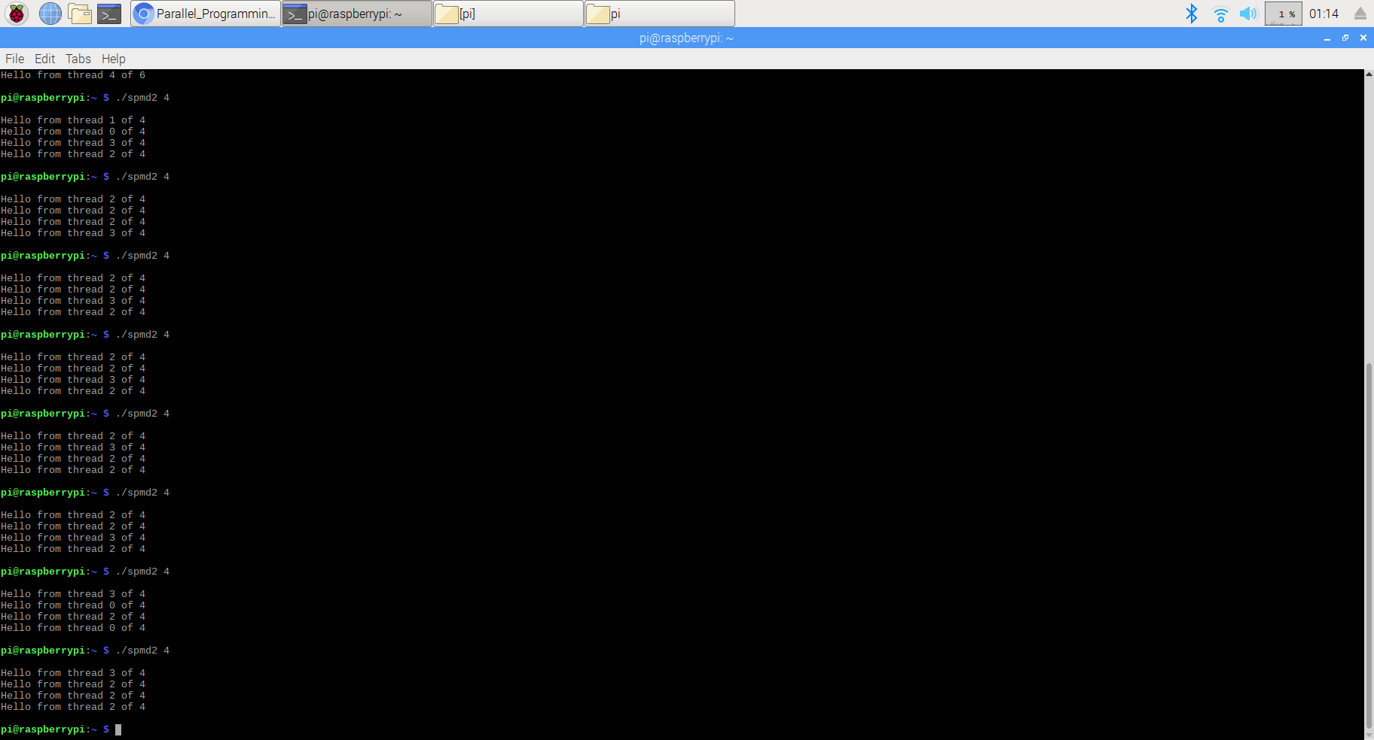

Here, I execute the program with input 4 for several times. However, the result is different every time. One thread id is appearing more than once sometimes. This shows that the program is not doing parallel programming properly. Sometimes one thread is doing the task multiple times while some other threads are not used at all.

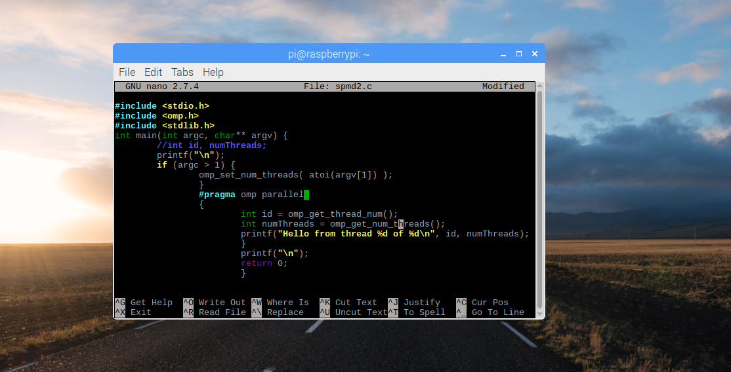

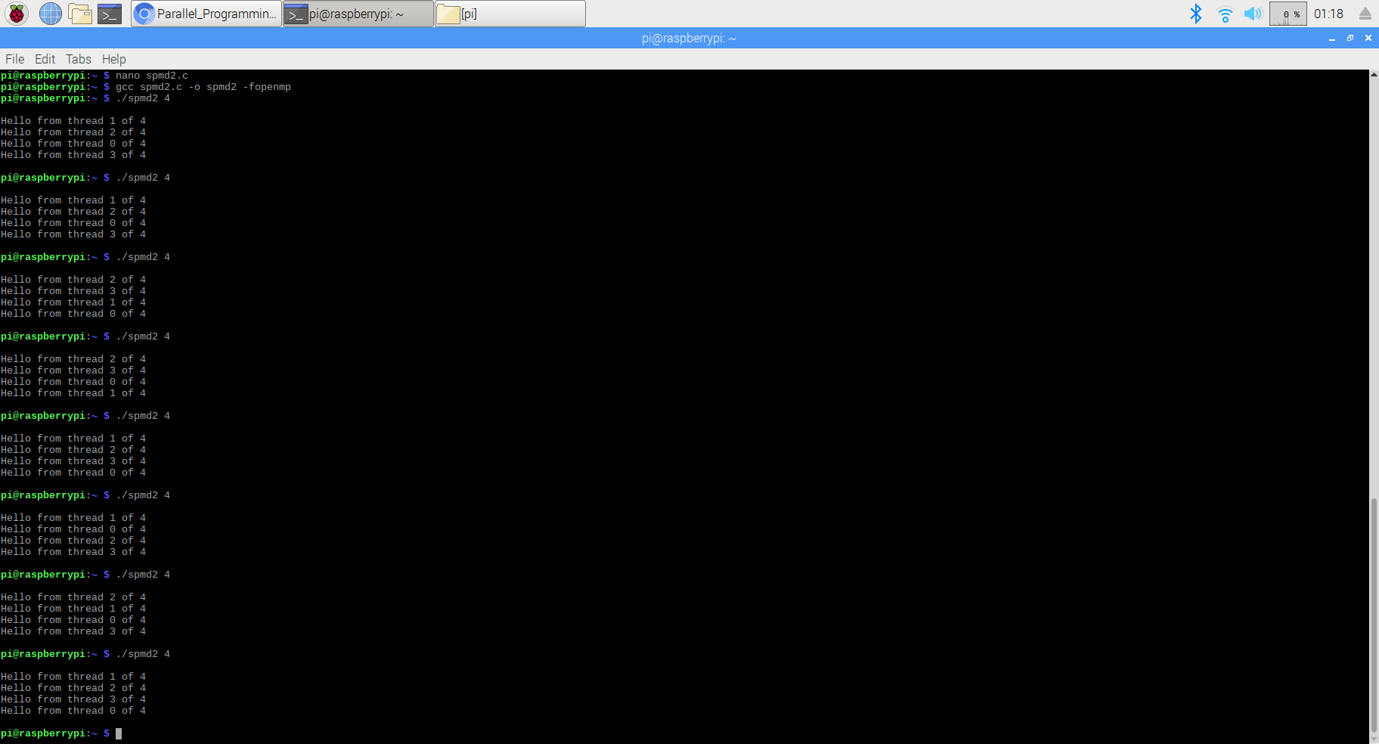

Here, I deleted the line where we declared variable in one thread on one core, which is outside of the block. Because this line of code will make all threads share that variable’s memory location. We want to make sure that each thread is keep tracking its id separately. So that I declared the variable inside of each block when we doing parallel computing. Now we get the same unique thread numbers printed out every time, which proved that this is a parallel program.